A

PROJECT CODE FILE

On

Credit Card Fraud Detection System
Elements of AIML
(CSAI2018_3)

School of Computer Science, UPES, Dehradun.

B.TECH. - II Semester

Jan. – May (2026)

Submitted to:  Dr. Vineet Jaiswal  Assistant Professor  SoCS, UPES | Submitted by:  Name SAP ID  Alankrita Vasishth 590022944  Bhavya Singh 590022993  Rachit Kumar 590023269  Vatsal Agarwal 590023223

INDEX
Sr No. | CHAPTERS | PAGE NO.
1. | METHODOLOGY | 3
2. | DATASET USED | 4
3. | BACKEND IMPLEMENTATION | 5-8
4. | FRONTEND IMPLIMENTATION | 9-16

METHODOLOGY

- Dataset Used :
- The project uses two datasets:
- creditcard.csv → Used as the training dataset
- test_transactions.csv → Used as the testing dataset
- The training dataset contains historical transaction data with labeled classes (fraud/normal)
- The testing dataset is used to simulate real-time transaction analysis
- Features include Time, Amount, and V1–V28 (anonymized variables)

- Data Preprocessing :
- Removed the target column (Class) from input features
- Applied StandardScaler to normalize feature values
- Ensured both datasets have the same structure and feature order
- Handled missing or unnecessary columns during testing

- Backend Implementation :
- The backend is implemented using app.py
- Built using Flask framework and Python
- Responsibilities:
- Load and train the machine learning model
- Process uploaded test dataset
- Perform predictions using Logistic Regression
- Return results in JSON format

- Model outputs:
- Fraud prediction (0 or 1)
- Fraud probability
- Risk level (Low / Medium / High)

- Frontend Implementation :
- The frontend is implemented using index.html
- Built using HTML, CSS, and JavaScript
- Responsibilities:
- Provide user interface for file upload
- Send data to backend using HTTP request
- Display results in dashboard format
- Show summary (total, fraud, normal transactions)
- Present transaction details in a table with risk indicators
DATASET USED

- creditcard.csv (Training Dataset)
    - Contains historical transaction data
    - Used to train the machine learning model
    - Highly imbalanced dataset (fraud cases are very few)
    - Total features: 30+ columns
Key Features :
- Time → Time elapsed since first transaction
- Amount → Transaction amount
- V1 to V28 → Anonymized features (PCA transformed for privacy)
- Class → Target variable
- 0 → Normal transaction
- 1 → Fraud transaction

- test_transactions.csv (Testing Dataset)
      - Used for real-time prediction (input by user)
      - Simulates new/unseen transactions
      - Same structure as training dataset (except Class may be absent)
Key Features :
- Time → Transaction time
- Amount → Transaction value
- V1 to V28 → Input features for prediction
- Class → Used only for testing accuracy (not required)

BACKEND IMPLIMENTATION

import pandas as pd
import numpy as np
from flask import Flask, request, jsonify, render_template
from sklearn.linear_model import LogisticRegression
from sklearn.preprocessing import StandardScaler
import os

app = Flask(__name__)

# Global variables (learned in Unit 2: Collections and Functions)
model = None
scaler = None

def train_model():
"""Trains the model using logic from your Experiment 7 and 10."""
global model, scaler

# Check if file exists (Unit 3: File Handling)
if not os.path.exists("creditcard.csv"):
print("Error: creditcard.csv not found in the project folder.")
return

print("Loading dataset for training...")
# Load data using Pandas (CO5: Data Manipulation)
df = pd.read_csv("creditcard.csv")

# Features (X) are all columns except 'Class'
# Target (y) is the 'Class' column (0=Normal, 1=Fraud)
X = df.drop("Class", axis=1)
y = df["Class"]

# Scaling (Experiment 7: Preprocessing)
# StandardScaler makes sure the 'Amount' column doesn't overpower others
scaler = StandardScaler()
X_scaled = scaler.fit_transform(X)

# Training (Experiment 6: Elements of AIML)
print("Training Logistic Regression model...")
model = LogisticRegression(max_iter=1000)
model.fit(X_scaled, y)
print("Model is ready! Open http://127.0.0.1:5000 in your browser.")

@app.route("/")
def index():
"""Displays your HTML dashboard."""
return render_template("index.html")

@app.route("/analyze", methods=["POST"])
def analyze():
"""Receives your test CSV and returns JSON for the HTML dashboard."""
if model is None:
return jsonify({"error": "Model not trained yet."}), 500

# Get the file from the request
file = request.files.get("file")
if not file:
return jsonify({"error": "No file uploaded."}), 400

try:
# Read the test data
df_test = pd.read_csv(file)

# We ignore the 'Class' column if it exists in the test file
X_input = df_test.drop("Class", axis=1) if "Class" in df_test.columns else df_test

# Scale using the training scaler
X_test_scaled = scaler.transform(X_input)

# Get Predictions and Probabilities
predictions = model.predict(X_test_scaled)
probabilities = model.predict_proba(X_test_scaled)[:, 1]

results = []
for i in range(len(df_test)):
prob = float(probabilities[i])

# Logic for Risk Level in your HTML
if prob >= 0.7:
risk = "HIGH"
elif prob >= 0.3:
risk = "MEDIUM"
else:
risk = "LOW"

results.append({
"transaction_id": i + 1,
"amount": round(float(df_test["Amount"].iloc[i]), 2),
"time": int(df_test["Time"].iloc[i]),
"fraud_probability": round(prob * 100, 1),
"prediction": int(predictions[i]),
"risk_level": risk
})

# Summary for the top dashboard cards
summary = {
"total": len(results),
"fraud_count": int(sum(predictions)),
"normal_count": len(results) - int(sum(predictions)),
}

return jsonify({"results": results, "summary": summary})

except Exception as e:
return jsonify({"error": f"Analysis failed: {str(e)}"}), 500

if __name__ == "__main__":
train_model()
app.run(debug=True)
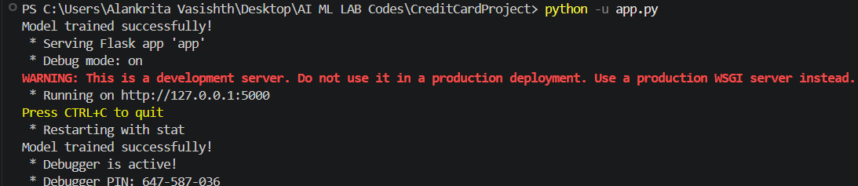
OUTPUT

FRONTEND DASHBOARD

<!DOCTYPE html>
<html lang="en">
<head>
<meta charset="UTF-8">
<meta name="viewport" content="width=device-width, initial-scale=1.0">
<title>Fraud Detection System</title>
<style>
/* Color Palette and Variables */
:root {
--primary-dark: #2c3e50;
--accent-blue: #3498db;
--danger: #e74c3c; /* Red for High Risk */
--warning: #f39c12; /* Orange for Medium Risk */
--success: #27ae60; /* Green for Low Risk */
--light-bg: #f8f9fa;
}

body {
font-family: 'Segoe UI', Arial, sans-serif;
background-color: #ecf0f1;
margin: 0;
padding: 40px;
color: var(--primary-dark);
}

.container {
max-width: 1000px;
margin: 0 auto;
background: white;
padding: 30px;
border-radius: 12px;
box-shadow: 0 10px 25px rgba(0,0,0,0.1);
}

h2 { border-bottom: 2px solid var(--light-bg); padding-bottom: 10px; }

/* Upload Section */
.upload-card {
background: var(--light-bg);
padding: 25px;
border-radius: 8px;
text-align: center;
border: 2px dashed #bdc3c7;
margin-bottom: 30px;
}

button {
background-color: var(--accent-blue);
color: white;
border: none;
padding: 12px 24px;
border-radius: 6px;
cursor: pointer;
font-weight: 600;
transition: background 0.3s;
}
button:hover { background-color: #2980b9; }

/* Summary Stats */
.summary-container {
display: flex;
gap: 20px;
margin-bottom: 30px;
}

.stat-card {
flex: 1;
padding: 20px;
border-radius: 8px;
text-align: center;
background: white;
border: 1px solid #eee;
}

.stat-card h3 { margin: 0; font-size: 14px; text-transform: uppercase; color: #7f8c8d; }
.stat-card span { font-size: 28px; font-weight: bold; display: block; margin-top: 5px; }

#fraud { color: var(--danger); }
#normal { color: var(--success); }

/* Table Styling */
table {
width: 100%;
border-collapse: collapse;
margin-top: 10px;
}
th {
background-color: var(--primary-dark);
color: white;
text-align: left;
padding: 15px;
}

td { padding: 12px 15px; border-bottom: 1px solid #eee; }

/* Risk Badges */
.risk-badge {
padding: 5px 10px;
border-radius: 20px;
font-size: 12px;
font-weight: bold;
color: white;
text-transform: uppercase;
}

.HIGH { background-color: var(--danger); }
.MEDIUM { background-color: var(--warning); }
.LOW { background-color: var(--success); }

.loading-text { display: none; color: var(--accent-blue); font-weight: bold; }
</style>
</head>
<body>

<div class="container">
<h2>Transaction Analysis Dashboard</h2>
<div class="upload-card">
<form id="uploadForm">
<input type="file" id="fileInput" accept=".csv" required>
<button type="submit" id="btnText">Run Analysis</button>
</form>
<p id="loading" class="loading-text">Analyzing patterns... please wait.</p>
</div>

<div class="summary-container">
<div class="stat-card">
<h3>Total Analyzed</h3>
<span id="total">0</span>
</div>
<div class="stat-card">
<h3>Fraud Suspected</h3>
<span id="fraud">0</span>
</div>
<div class="stat-card">
<h3>Normal</h3>
<span id="normal">0</span>
</div>
</div>

<h3>Transaction Detail</h3>
<table>
<thead>
<tr>
<th>ID</th>
<th>Amount</th>
<th>Fraud Probability</th>
<th>Result</th>
<th>Risk Level</th>
</tr>
</thead>
<tbody id="tableBody"></tbody>
</table>
</div>

<script>
document.getElementById("uploadForm").addEventListener("submit", function(e) {
e.preventDefault();

const file = document.getElementById("fileInput").files[0];
const loading = document.getElementById("loading");
const btnText = document.getElementById("btnText");

loading.style.display = "block";
btnText.disabled = true;

let formData = new FormData();
formData.append("file", file);

fetch("/analyze", {
method: "POST",
body: formData
})
.then(res => res.json())
.then(data => {
loading.style.display = "none";
btnText.disabled = false;

if(data.error) {
alert(data.error);
return;
}

// Summary Update
document.getElementById("total").innerText = data.summary.total;
document.getElementById("fraud").innerText = data.summary.fraud;
document.getElementById("normal").innerText = data.summary.normal;

// Table Update
let table = document.getElementById("tableBody");
table.innerHTML = "";

data.results.forEach(row => {
let tr = `
<tr>
<td>#${row.id}</td>
<td>$${row.amount.toLocaleString()}</td>
<td>${row.fraud_probability}%</td>
<td>${row.prediction === 1 ? '🚩 Flagged' : '✅ Verified'}</td>
<td><span class="risk-badge ${row.risk}">${row.risk}</span></td>
</tr>
`;
table.innerHTML += tr;
});
})
.catch(err => {
console.error(err);
loading.style.display = "none";
btnText.disabled = false;
});
});
</script>

</body>
</html>

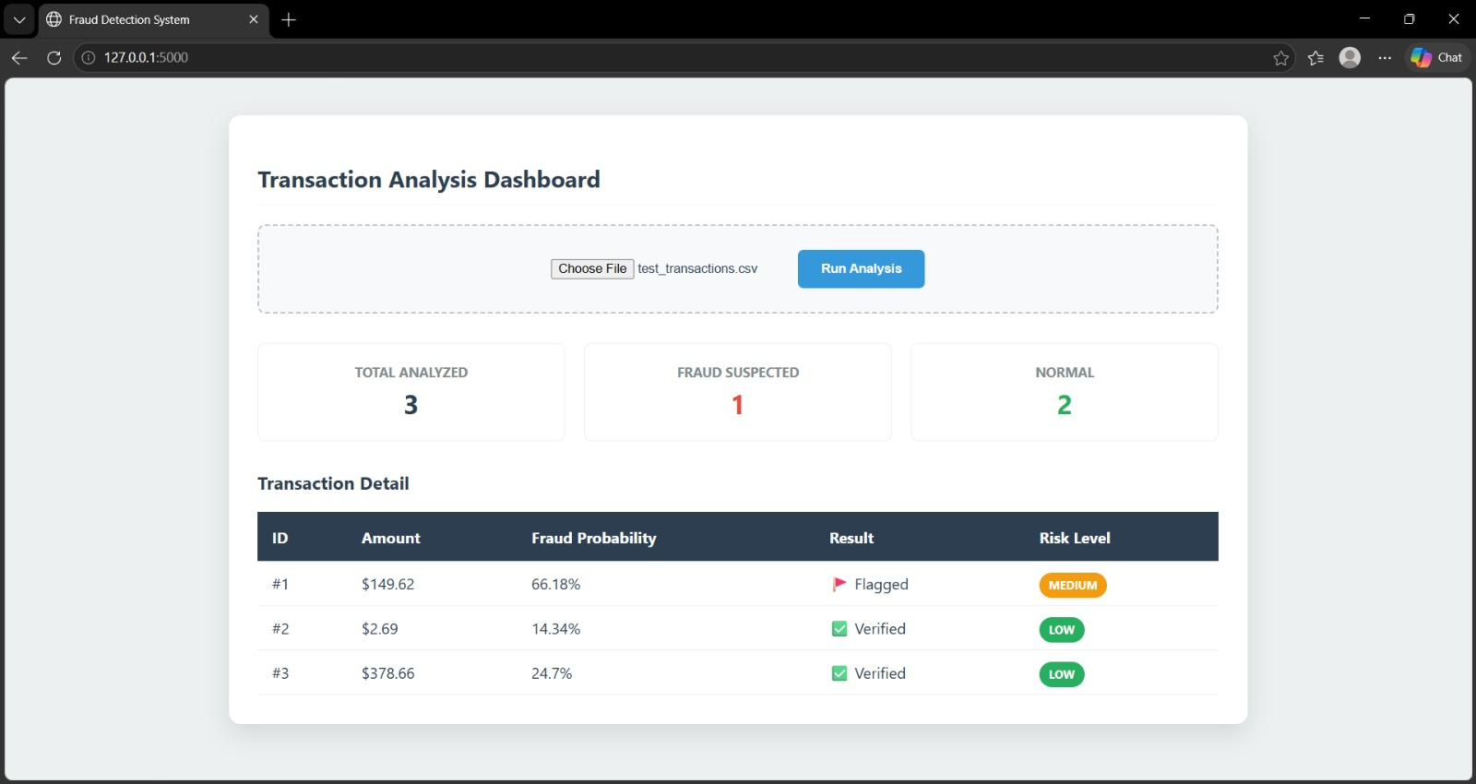
OUTPUT

